**Year 8 Chemistry Mid Topic Test 2013**

Name:_________________________ Mark: /50

**Multiple choice answer grid**

**1** A B C D

**2** A B C D

**3** A B C D

**4** A B C D

**5** A B C D

**6** A B C D

**7** A B C D

**8** A B C D

**9** A B C D

**10** A B C D

**11** A B C D

**12** A B C D

**13** A B C D

**14** A B C D

**15** A B C D

**16** A B C D

**17** A B C D

**1** Which of the following is a chemical change?

A Sawdust is produced from wood being cut by a power saw.

B Water freezes to form ice.

C Fireworks explode in a colourful light display.

D Juice is obtained from an orange.

**2** Describe the particles in a solid.

A The particles in a solid are strongly bonded to each other so the solid has a definite shape.

B The particles in a solid are strongly bonded to each other so the solid does not have a definite shape.

C The particles in a solid are weakly bonded to each other so the solid has a definite shape.

D The particles in a solid are weakly bonded to each other so the solid does not have a definite shape.

**3** Identify why gases are easily compressed.

A the particles can diffuse

B there is pressure between particles squashing them together

C there is great energy between the particles allowing them to change

D there is a lot of space between the particles

**4** Define melting point.

A Melting point is the temperature at which a liquid changes to a gas.

B Melting point is the temperature at which a solid changes to a gas.

C Melting point is the temperature at which a liquid changes to a solid.

D Melting point is the temperature at which a solid changes to a liquid.

**5** What is the scientific term for the process where by two liquids or gases mix due to the motion of their particles

A evaporation

B diffusion

C condensation

D solution

**6** A permanent colour change may be an indication that a chemical reaction has taken place. Identify which of the following is **not** an indication of a chemical reaction.

A sugar caramelising (cooking and turning brown)

B toasting bread

C a glass breaking

D burning a match

**7** Analyse the word equation:

methane + oxygen → carbon dioxide + water + energy

This reaction shows that:

A oxygen is a product of this reaction.

B methane burns with a sooty flame.

C this is an exothermic reaction.

D a constant input of energy is required to keep the reaction going.

**8** As a solid object is heated, its particles:

A vibrate less rapidly and cause it to contract.

B vibrate more rapidly and cause it to expand.

C attract each other more, causing contraction.

D shrink in size so the gaps between them increase.

**9** A stone has a volume of 6 cubic centimetres and a mass of 12 grams. Its density is:

A 2.00 g/cm3

B 0.50 g/cm3

C 17 g/cm3

D 66 g/cm3

**10** Identify which of the following would indicate an endothermic reaction.

A a gas is given off

B the reaction glows

C a precipitate forms

D the reaction feels cold to the touch

**11** Jackson collected some snow and placed it in a beaker. During the day it melted to produce clear water. Jackson and his friends made the following comments about the process.

Jackson: This is a chemical change as there is a change in colour.

Nymunday: The beaker is now warmer than when you collected the snow. This must be a chemical change as energy is absorbed.

Leah: This is a physical change as the trapped air bubbles react with the snow.

James: This is a physical change as no new substances are created.

[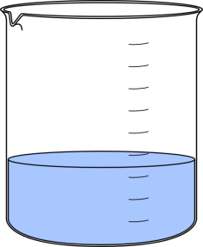](http://www.google.com.au/url?sa=i&rct=j&q=beaker&source=images&cd=&cad=rja&docid=BW6nphAnR-n0BM&tbnid=s-tEb7glLRZjtM:&ved=0CAUQjRw&url=http://www.clker.com/clipart-lab-beaker.html&ei=awMcUqOaA8flkAWztoH4Dg&psig=AFQjCNHxNAnKDcznI6ICGJh0QfeXYI4VMw&ust=1377653981173171)State who you believe is correct.

A Jackson

B Nymunday

C Leah

D James

**12** Solene was sitting by a warm fire. The reaction she could see was:

[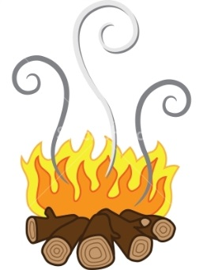](http://www.google.com.au/url?sa=i&rct=j&q=log+fire&source=images&cd=&cad=rja&docid=FGxFYNf3-XN-iM&tbnid=gigPgoC5-ef19M:&ved=0CAUQjRw&url=http://www.stockphotopro.com/photo_of/smoke/47991394VAC/A_log_fire_giving&ei=EAMcUunUDoejkwW6yIGQDg&psig=AFQjCNHb-y48oo1-8LLjOL_kLmXAMl_8Dg&ust=1377653888154741)A Corrosion

B Spontaneous

C Non-Spontaneous

D Physical Change

**13** An object will float in a liquid if the object is less dense than the liquid. It will sink if the object is denser than the liquid. Four identical balls are dropped in four different liquids shown below. Which liquid is most dense?

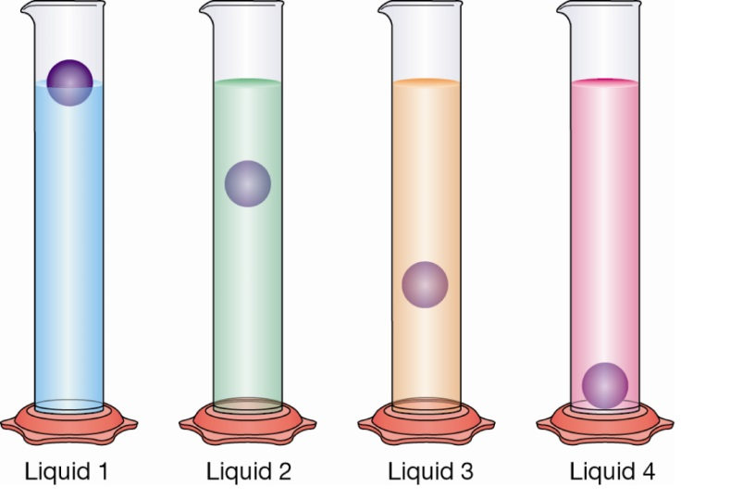

A liquid 1

B liquid 2

C liquid 3

D liquid 4

**14** Matter can be solid, liquid or gas. These are known as the states of matter

Below -78.5°C carbon dioxide (CO2) is a solid. Above this temperature it is a gas. Determine which process carbon dioxide would undergo as the temperature is raised from -80°C to -75°C.

A evaporation

B sublimation

C melting

D condensation

**15** Jaylen carries out an experiment to determine the effect of different types of salt solutions on an iron nail. Identify the purpose of the test tube containing the nail and water only.

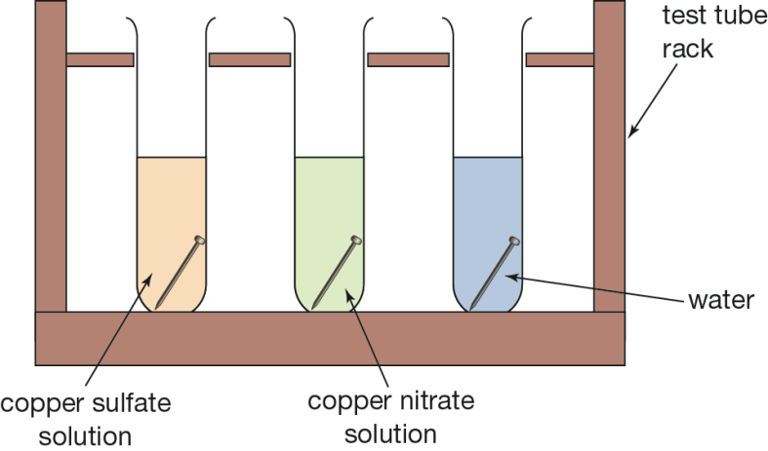

A The water is added to test the strength of the nail.

B All of the answers are correct.

C The test tube acts as a control for the experiment.

D This test tube allows a comparison between copper nitrate and copper sulphate.

**[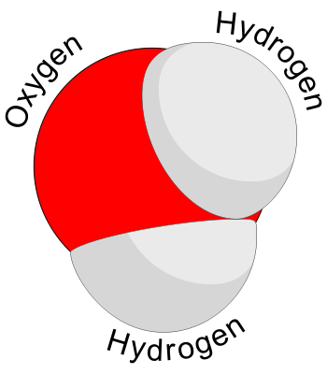](http://www.google.com.au/url?sa=i&rct=j&q=molecule&source=images&cd=&cad=rja&docid=nJD4iOsvbWrjXM&tbnid=0vKsvNnXoIgGEM:&ved=0CAUQjRw&url=http://www.webbofscience.com/2009/06/06/molecule-of-the-week-water/&ei=qRwUUs2NI8XNkwXr24GgDA&psig=AFQjCNGk0zhtDTBZU0Mi1OVQvLl8tANeNQ&ust=1377136159664223)16** Which of the following statements about the diagram to the right is **INCORRECT**?

A It is an element

B It is a molecule

C It is a compound

D It is water

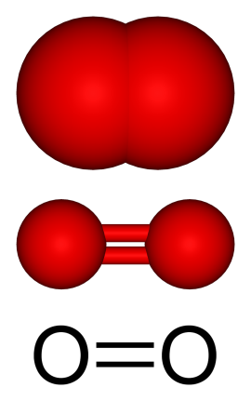**17** This diagram shows three different ways of drawing the **same** thing. Which of the following statements about the diagram to the right is **INCORRECT**?

A It is an element

B It is a molecule

C It is a compound

D It is oxygen gas

**1 Identify** the ‘states of matter’ and their changes on the diagram. Two of the arrows require you to state whether energy is increasing or decreasing (5)

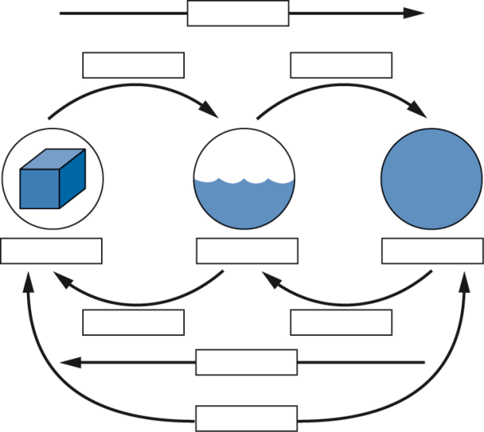

**2** **a** Calculate the density of a piece of glass with a mass of 24 g if its volume is 8 cm3. (3)

**b** Calculate the density of a cube of wood measuring 2 cm along each side, and having a mass of 11.2g. (3)

**3** Solid A has a density of 1.2 g/cm3, solid B has a density of 0.8 g/cm3 and solid C has a density of 1.5g/cm3.

All three are placed in liquid D which has a density of 1.2 g/cm3.

Predict the positions of the solids if they are placed in a beaker of the liquid. Draw a beaker showing your prediction. (3)

**4** Nicole placed Magnesium in a test tube with Hydrochloric acid. The magnesium fizzed and Hydrogen gas and Magnesium Chloride were produced.

**a.** Write a word equation to describe this: (2)

**b.** Write a formula equation (2)

**c.** What are the products in this equation? (1)

[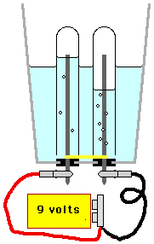](http://www.google.com.au/url?sa=i&rct=j&q=water+electrolysis&source=images&cd=&cad=rja&docid=BT3fXL7XeE4d-M&tbnid=NT4eU1HngGX77M:&ved=0CAUQjRw&url=http://www.science-projects.com/Electrolysis/eLysis.htm&ei=Kx4UUuCvF8v3lAX-tIDAAw&psig=AFQjCNFVuOIepla-9Mq2a2GPx3Cl9X4I0A&ust=1377136541971286)**5** Brody ran an electrical current through water as shown in the following diagram. Two gasses were produced.

**a.** What two gasses would have been produced? (2)

**b.** There was twice as much of one gas produced as the other. Which gas was there more of and why? (2)

**c.** Is this an example of a spontaneous or non-spontaneous reaction? Why? (2)

**d.** Write a word equation for the reaction Brody caused (2)

**e.** Write a formula equation for this reaction (2)

**[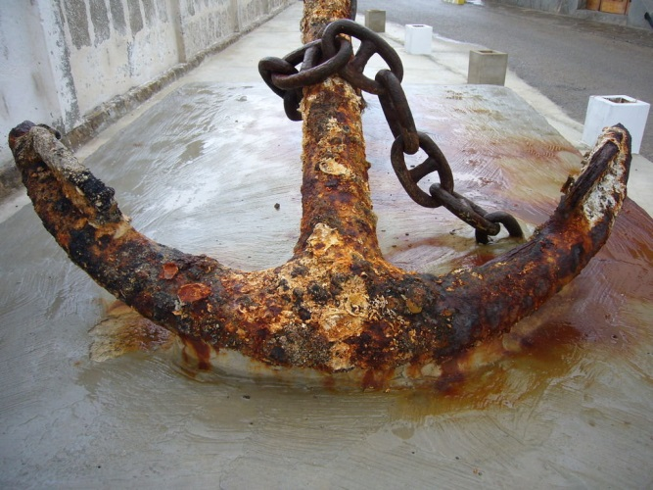](http://www.google.com.au/url?sa=i&rct=j&q=corrosion&source=images&cd=&cad=rja&docid=cia0k7nZeeYHiM&tbnid=BxyiJ9rF032tgM:&ved=0CAUQjRw&url=http://www.milesofsmilesdental.net/1248/risks-of-corrosion-with-titanium-dental-implants/&ei=uy0UUu_rEsj6kAW6noC4AQ&psig=AFQjCNEyliK8ztv0lifYmN1hN3HUm2WYBg&ust=1377140519523013)6** This is a picture of an iron anchor that has spent many years in the ocean.

**a.** What is the correct scientific term for the process that is occuring to the anchor causing the outer layers to flake off? (1)

**b.** Write a word equation to describe the process (2)

**c.** What is one thing that could be done to stop this reaction happening? (1)

**Year 8 Chemistry Mid Topic Test 2013 SOLUTIONS**

Name:_________________________ Mark: /50

**Multiple choice answer grid**

**1** A B C D

**2** A B C D

**3** A B C D

**4** A B C D

**5** A B C D

**6** A B C D

**7** A B C D

**8** A B C D

**9** A B C D

**10** A B C D

**11** A B C D

**12** A B C D

**13** A B C D

**14** A B C D

**15** A B C D

**16** A B C D

**17** A B C D

**Short Answers**

**1 Identify** the ‘states of matter’ and their changes on the diagram. Two of the arrows require you to state whether energy is increasing or decreasing (5)

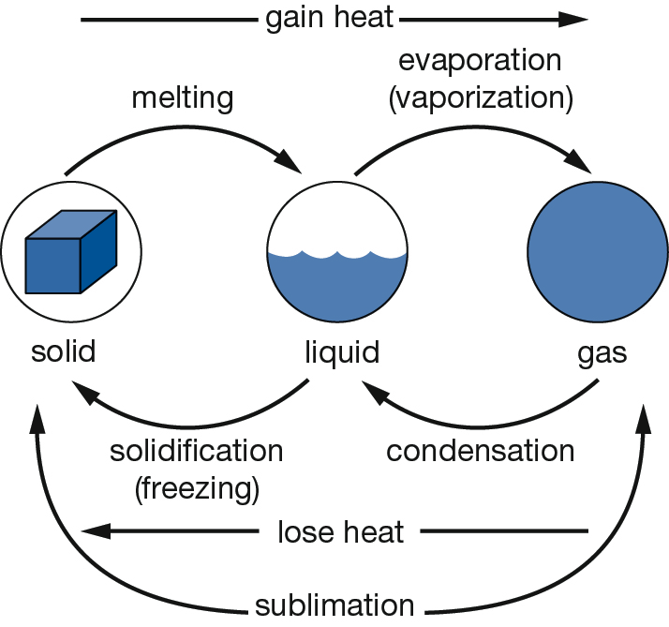

**2** **a** Calculate the density of a piece of glass with a mass of 24 g if its volume is 8 cm3. (3)

Must have working

Correct answer 3g/cm3

& units

**b** Calculate the density of a cube of wood measuring 2 cm along each side, and having a mass of 11.2g. (3)

Must have working for volume 2x2x2

Working for density

Correct answer with correct units 1.4g/cm3

**3** Solid A has a density of 1.2 g/cm3, solid B has a density of 0.8 g/cm3 and solid C has a density of 1.5g/cm3.

All three are placed in liquid D which has a density of 1.2 g/cm3.

Predict the positions of the solids if they are placed in a beaker of the liquid. Draw a beaker showing your prediction. (3)

One mark per item in correct position

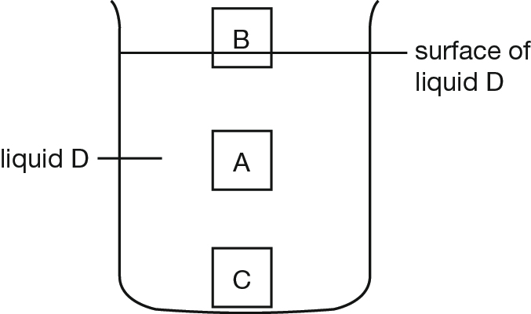

**4** Nicole placed Magnesium in a test tube with Hydrochloric acid. The magnesium fizzed and Hydrogen gas and Magnesium Chloride were produced.

**a.** Write a word equation to describe this: (2)

1 mark for correct words

1 mark for correct lay out

**b.** Write a formula equation (2)

Equation does not have to be balanced.

Correct symbols

Correct layout

**c.** What are the products in this equation? (1)

Hydrogen gas & Magnesium (1/2 mark each)

[](http://www.google.com.au/url?sa=i&rct=j&q=water+electrolysis&source=images&cd=&cad=rja&docid=BT3fXL7XeE4d-M&tbnid=NT4eU1HngGX77M:&ved=0CAUQjRw&url=http://www.science-projects.com/Electrolysis/eLysis.htm&ei=Kx4UUuCvF8v3lAX-tIDAAw&psig=AFQjCNFVuOIepla-9Mq2a2GPx3Cl9X4I0A&ust=1377136541971286)**5** Brody ran an electrical current through water as shown in the following diagram. Two gasses were produced.

**a.** What two gasses would have been produced? (2)

Oxygen gas & Hydrogen gas 1 mark each

**b.** There was twice as much of one gas produced as the other. Which gas was there more of and why? (2)

1 mark for mentioning formula

1 mark for explanation

**c.** Is this an example of a spontaneous or non-spontaneous reaction? Why? (2)

Non spontaneous 1 mark each

Continual input of electricity required

**d.** Write a word equation for the reaction Brody caused (2)

1 mark for correct words

1 mark for correct lay out

**e.** Write a formula equation for this reaction (2)

1 mark for correct symbols

1 mark for correct lay out

Equation does NOT have to be balanced

**[](http://www.google.com.au/url?sa=i&rct=j&q=corrosion&source=images&cd=&cad=rja&docid=cia0k7nZeeYHiM&tbnid=BxyiJ9rF032tgM:&ved=0CAUQjRw&url=http://www.milesofsmilesdental.net/1248/risks-of-corrosion-with-titanium-dental-implants/&ei=uy0UUu_rEsj6kAW6noC4AQ&psig=AFQjCNEyliK8ztv0lifYmN1hN3HUm2WYBg&ust=1377140519523013)6** This is a picture of an iron anchor that has spent many years in the ocean.

**a.** What is the correct scientific term for the process that is occuring to the anchor causing the outer layers to flake off? (1)

corrosion or oxidation

**b.** Write a word equation to describe the process (2)

metal + oxygen -> metal oxide

1 mark for reactants 1 mark for products

**c.** What is one thing that could be done to stop this reaction happening? (1)

any one of

coating

galvanisation

alloying